Evaluation: Random Forest
Accuracy: 0.9628
Precision: 0.9628991886958959
Recall: 0.9628
F1 Score: 0.9628253632085889
Jaccard Index: 0.9286380599535727
Matthews CorrCoef: 0.9535120143270712
Cohen’s Kappa: 0.9535
Specificity: 0.9907
AUC: 0.9981036
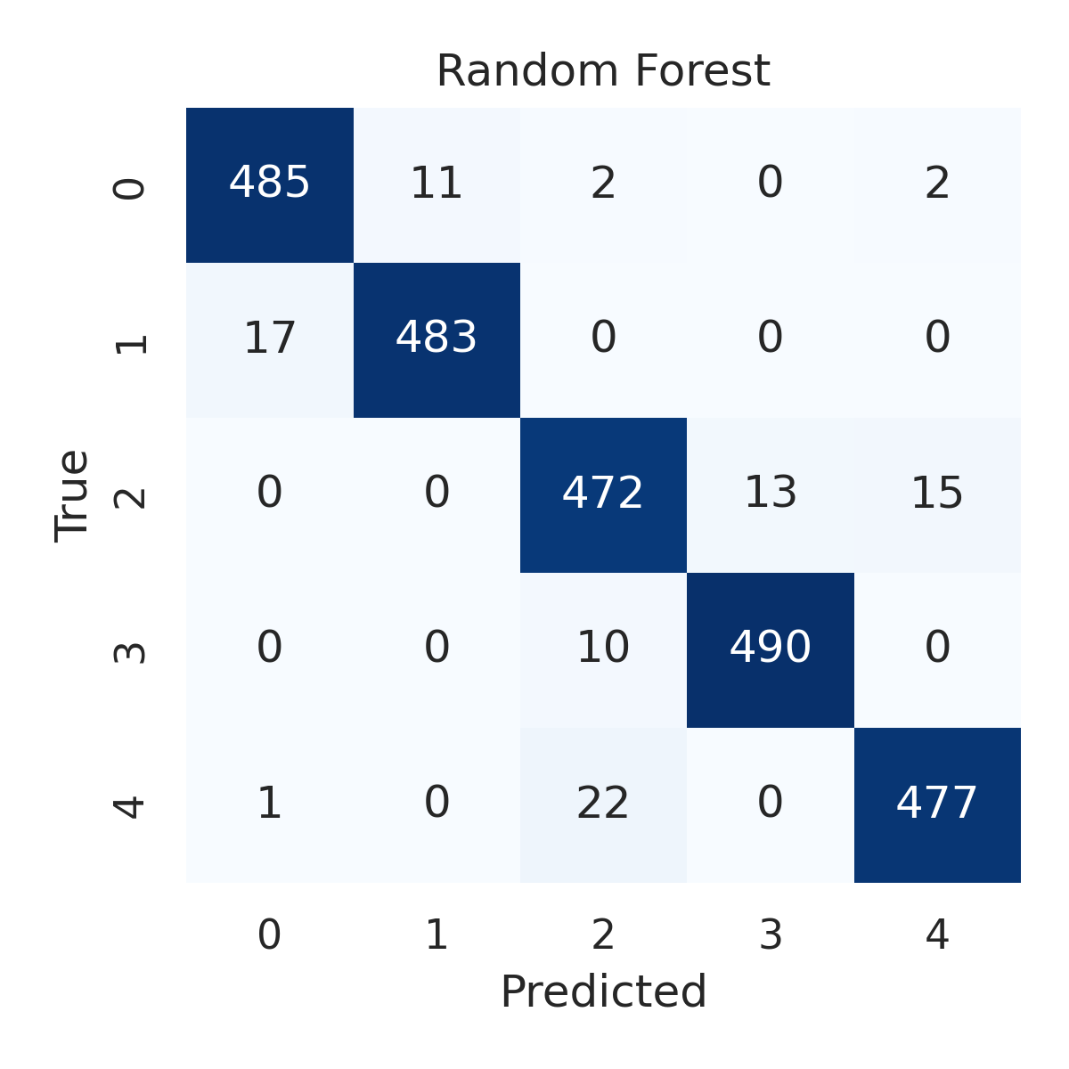

Combined ROC Curves
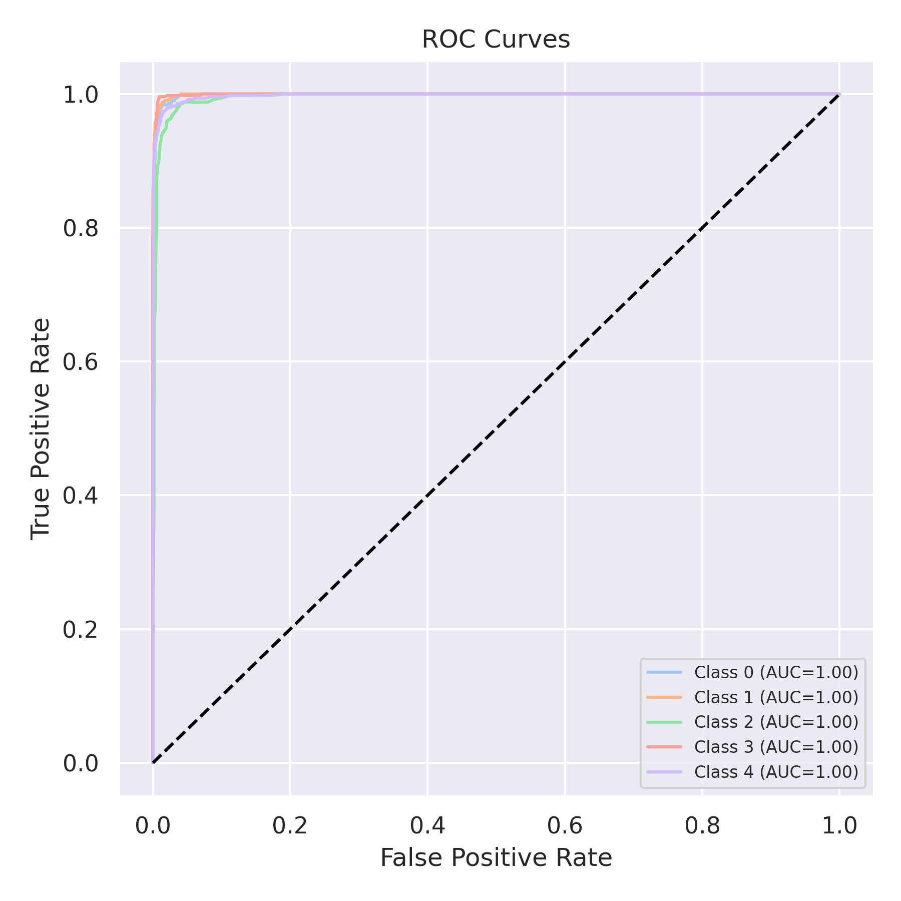

Evaluation: K-Nearest Neighbors
Accuracy: 0.8844
Precision: 0.8858241402989064
Recall: 0.8844
F1 Score: 0.8834473893799004
Jaccard Index: 0.7929033144844714
Matthews CorrCoef: 0.8562989571350202
Cohen’s Kappa: 0.8555
Specificity: 0.9711000000000001
AUC: 0.9825375999999999
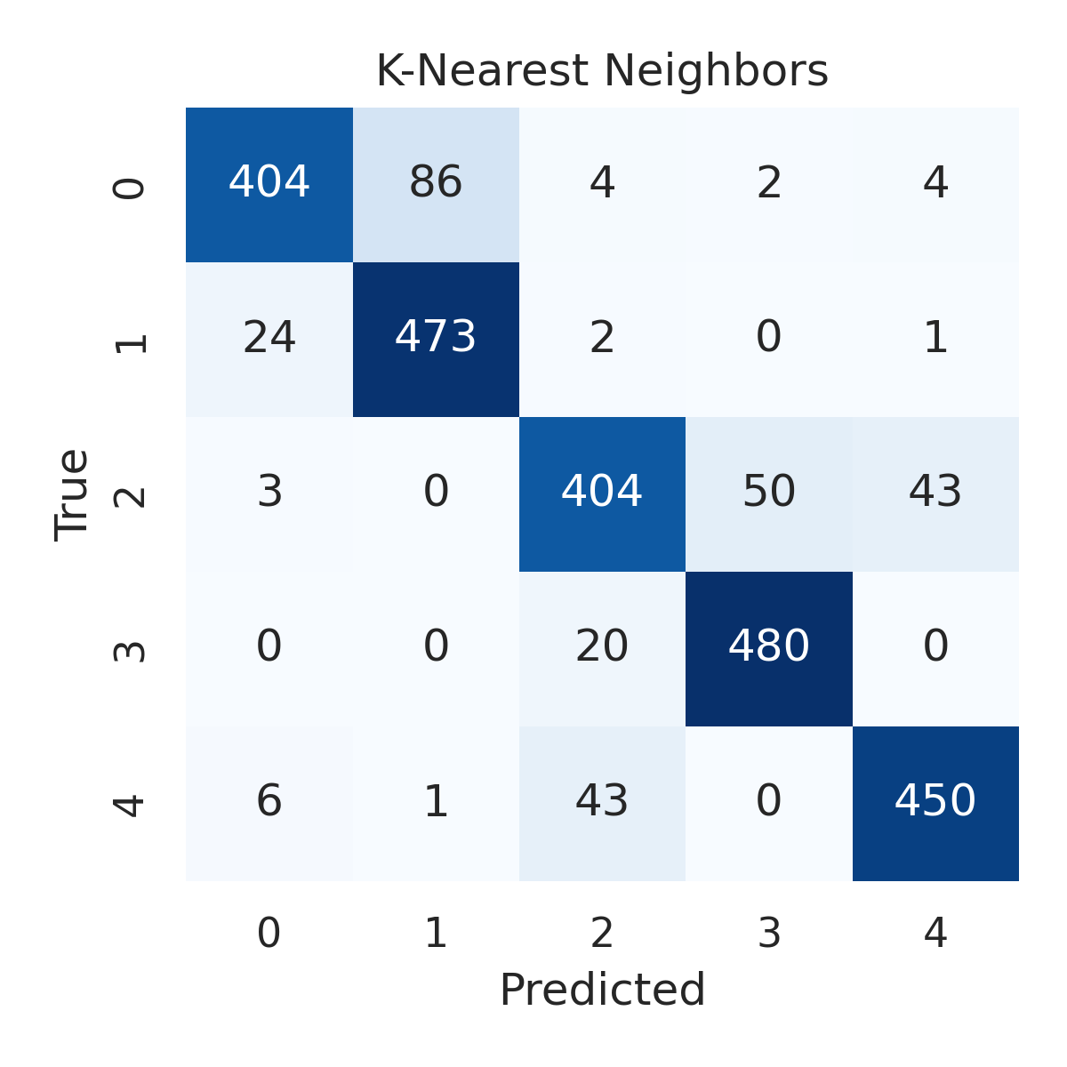

Combined ROC Curves
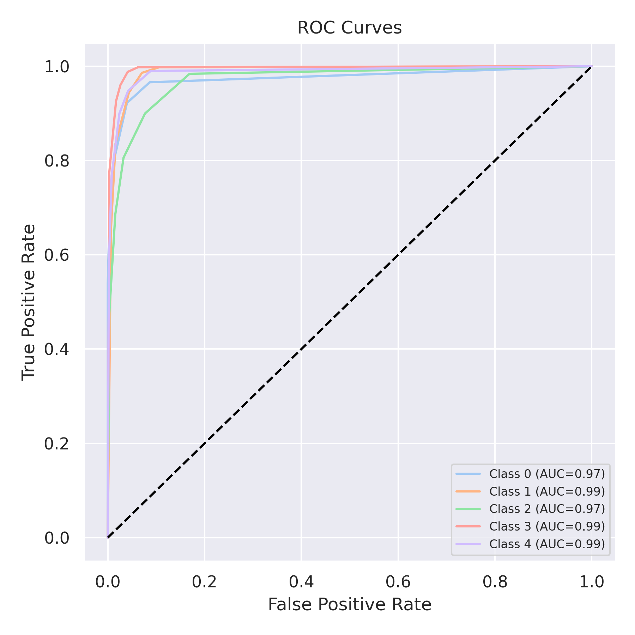

Evaluation: Decision Tree
Accuracy: 0.9604
Precision: 0.960672984068707
Recall: 0.9604
F1 Score: 0.9604981433483177
Jaccard Index: 0.9246531629112414
Matthews CorrCoef: 0.9505188204589694
Cohen’s Kappa: 0.9505
Specificity: 0.9901
AUC: 0.97525
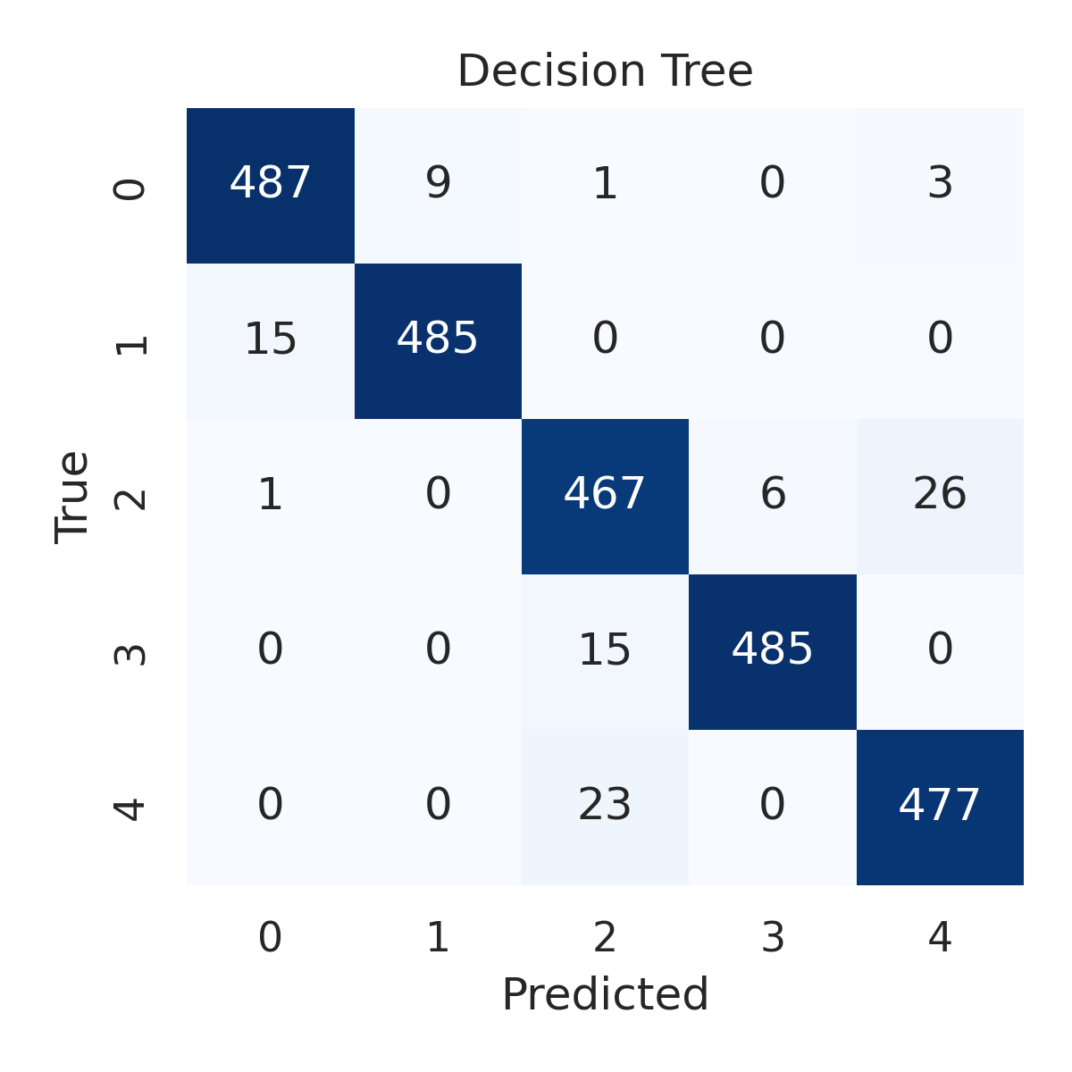

Combined ROC Curves
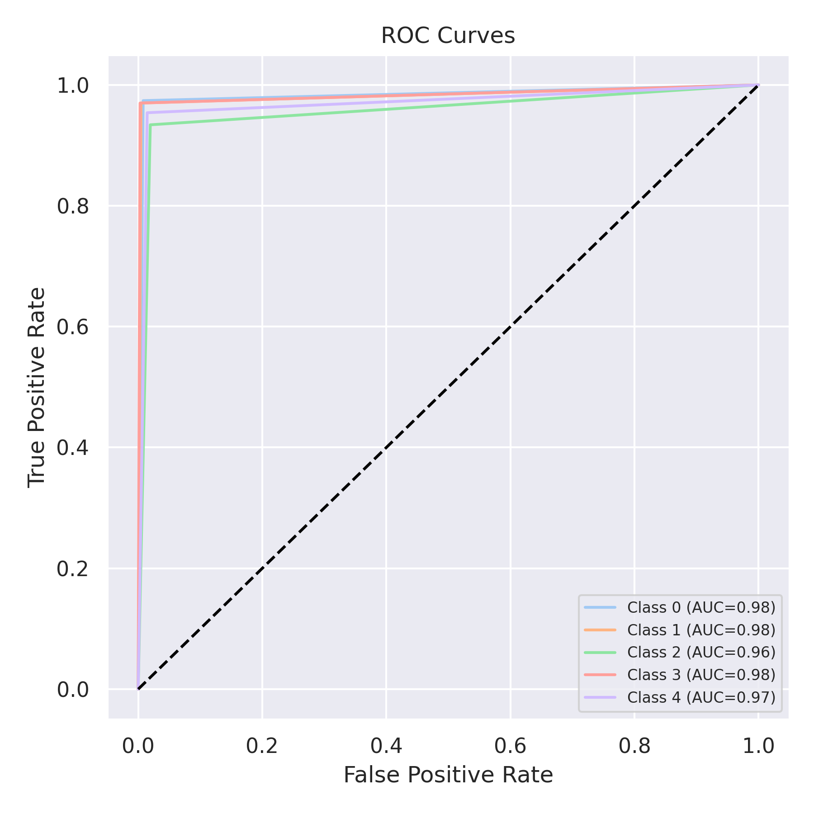

Evaluation: Extra Trees
Accuracy: 0.9692
Precision: 0.9692137719517808
Recall: 0.9692
F1 Score: 0.9691896030768976
Jaccard Index: 0.9405206419670685
Matthews CorrCoef: 0.9615084613116894
Cohen’s Kappa: 0.9615
Specificity: 0.9923
AUC: 0.9987753000000001
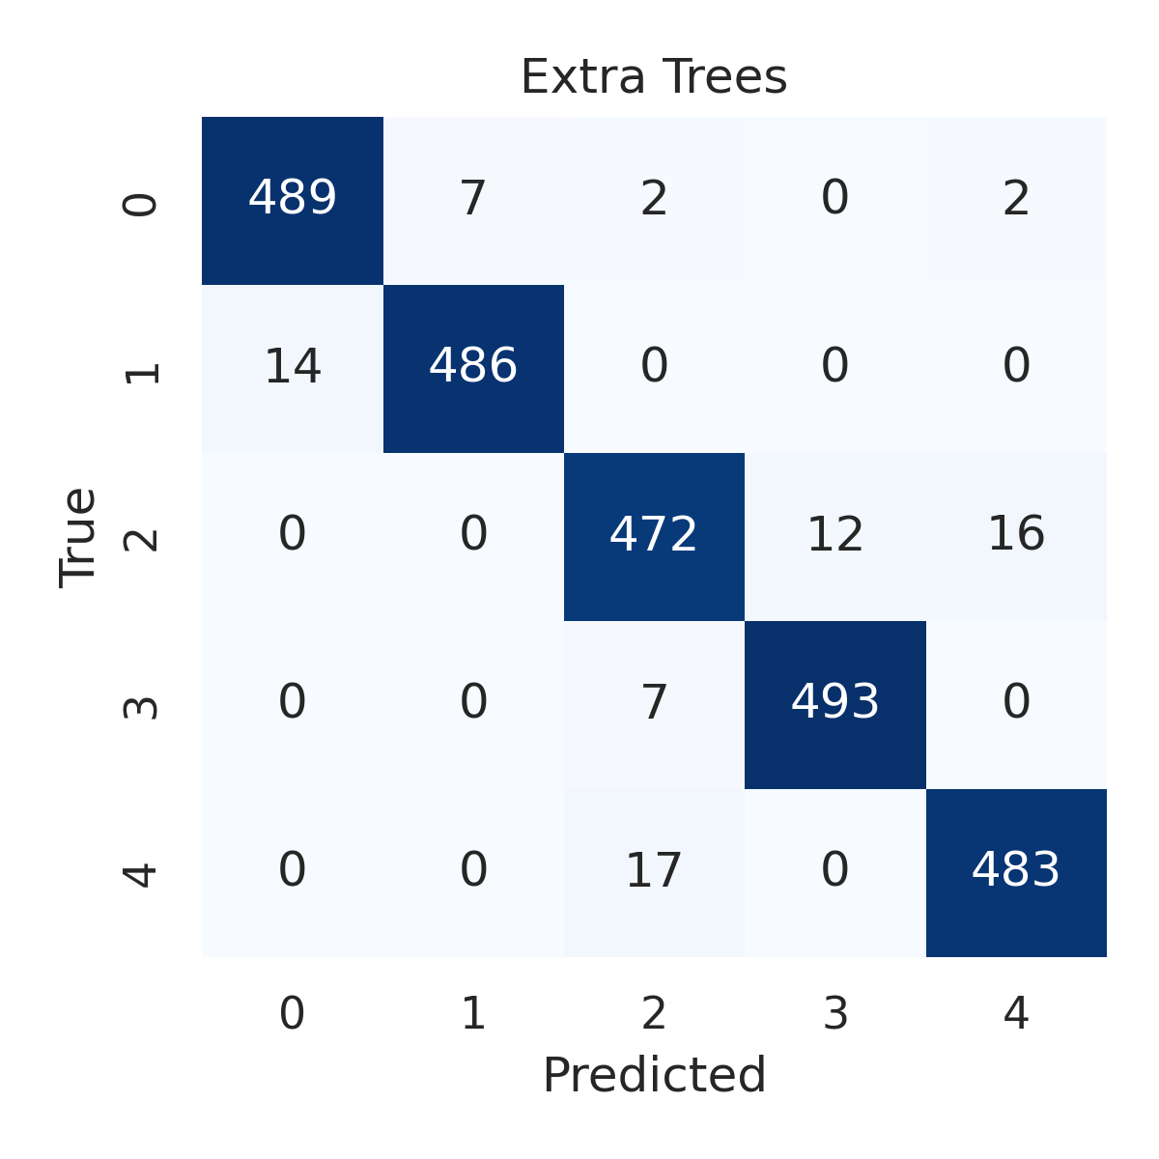

Combined ROC Curves
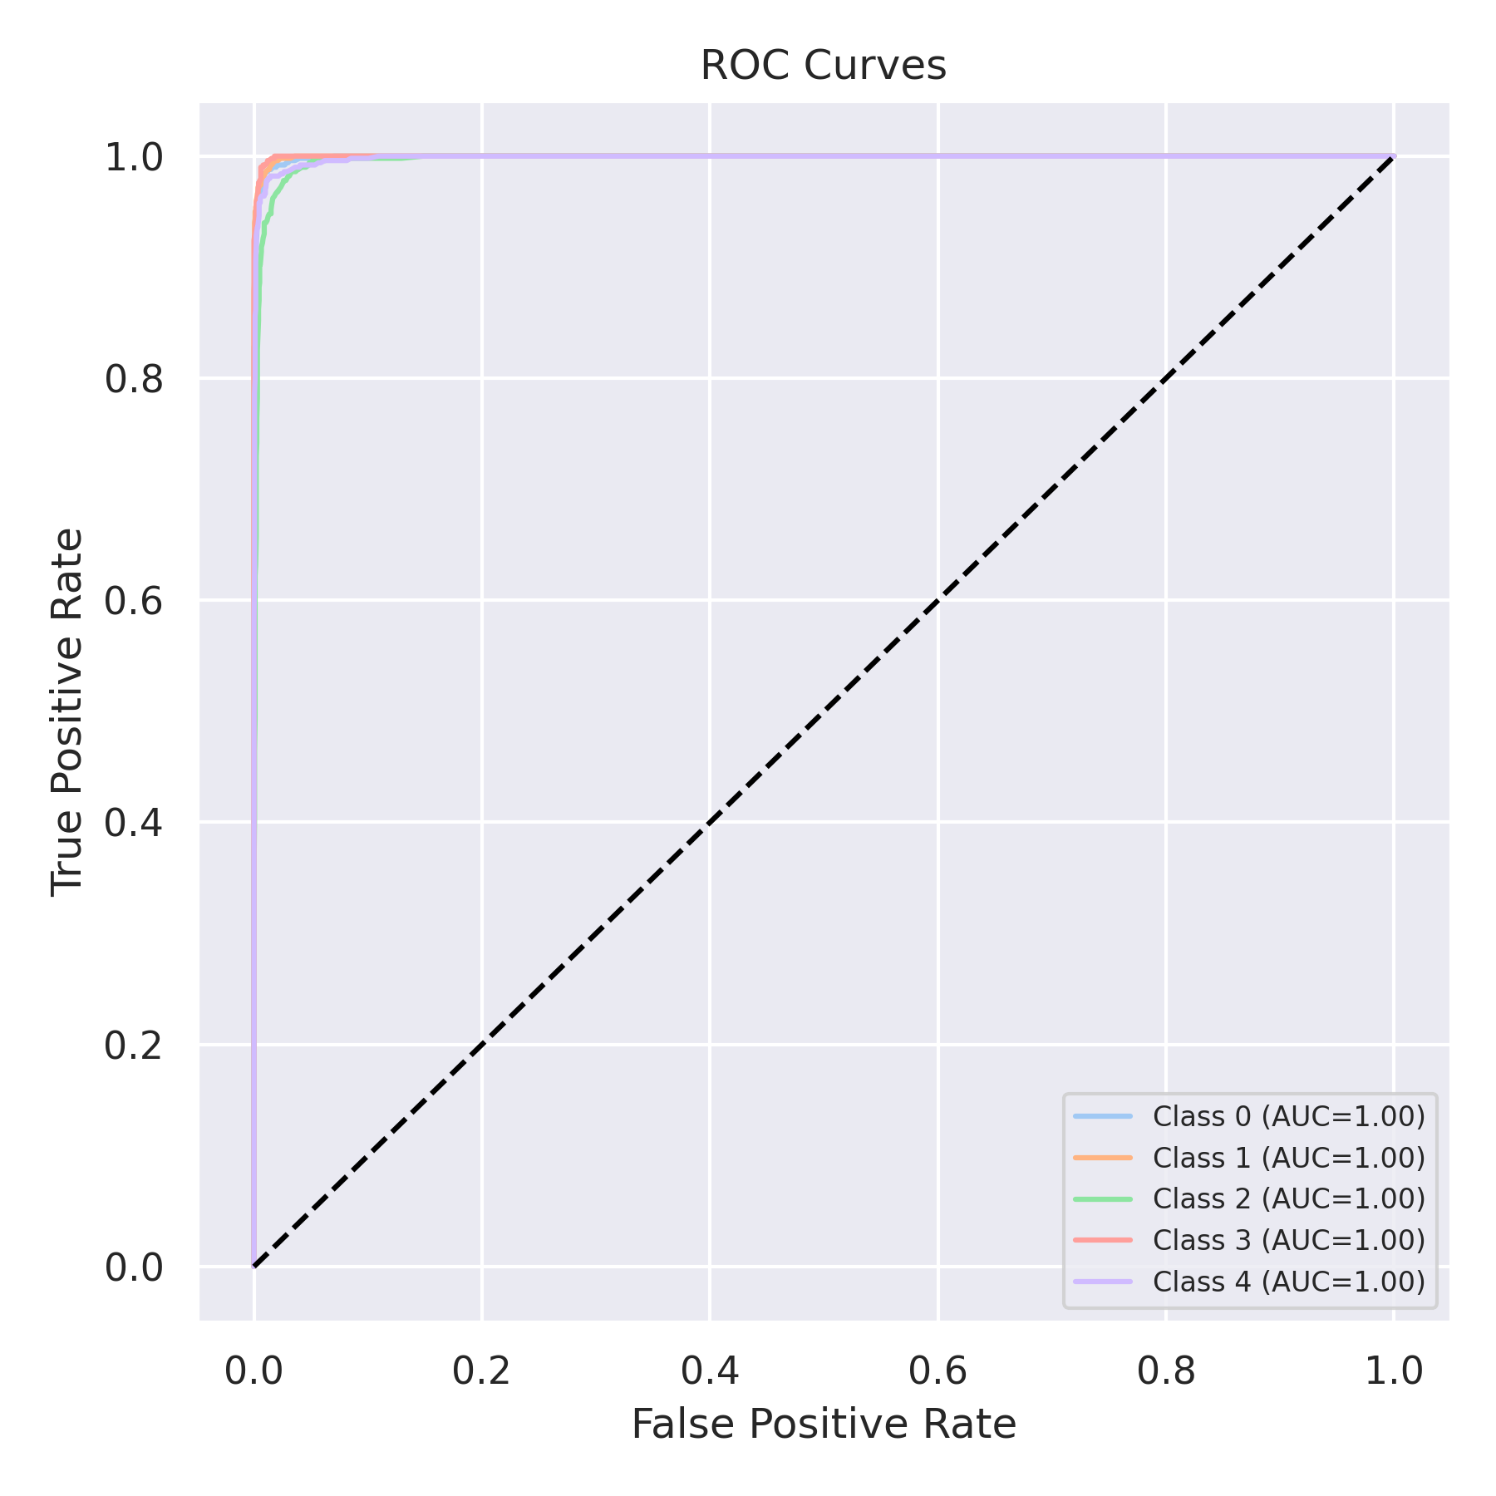

Evaluation: Bagging Classifier
Accuracy: 0.9732
Precision: 0.9734200439794293
Recall: 0.9732
F1 Score: 0.9732221671917985
Jaccard Index: 0.9480416630460393
Matthews CorrCoef: 0.9665440754147813
Cohen’s Kappa: 0.9665
Specificity: 0.9933
AUC: 0.9951264
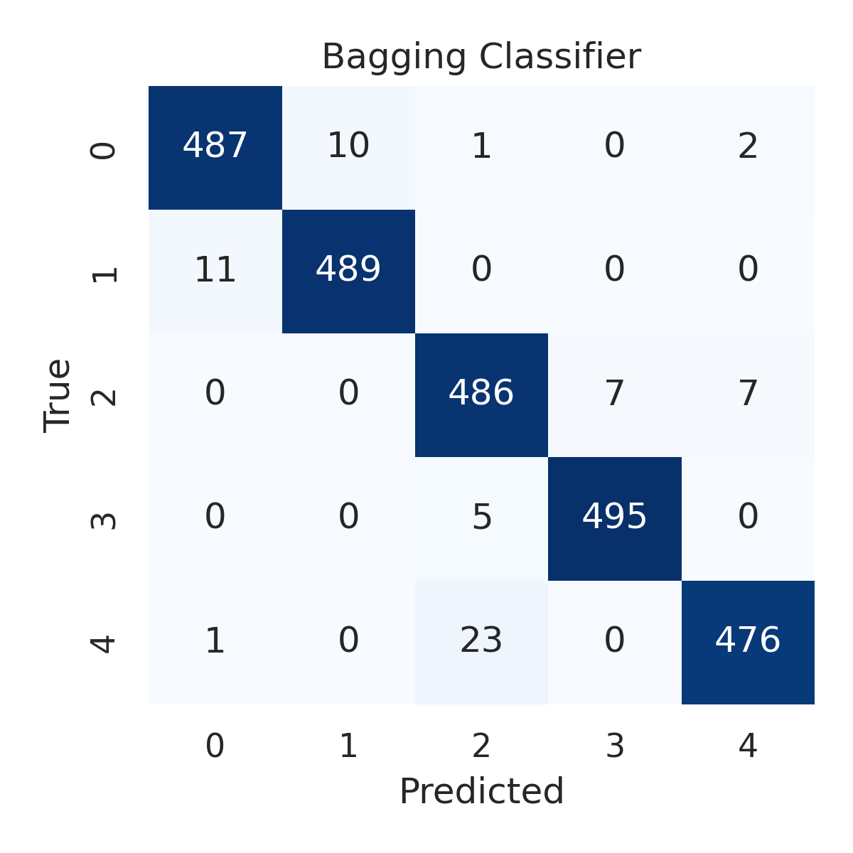

Combined ROC Curves
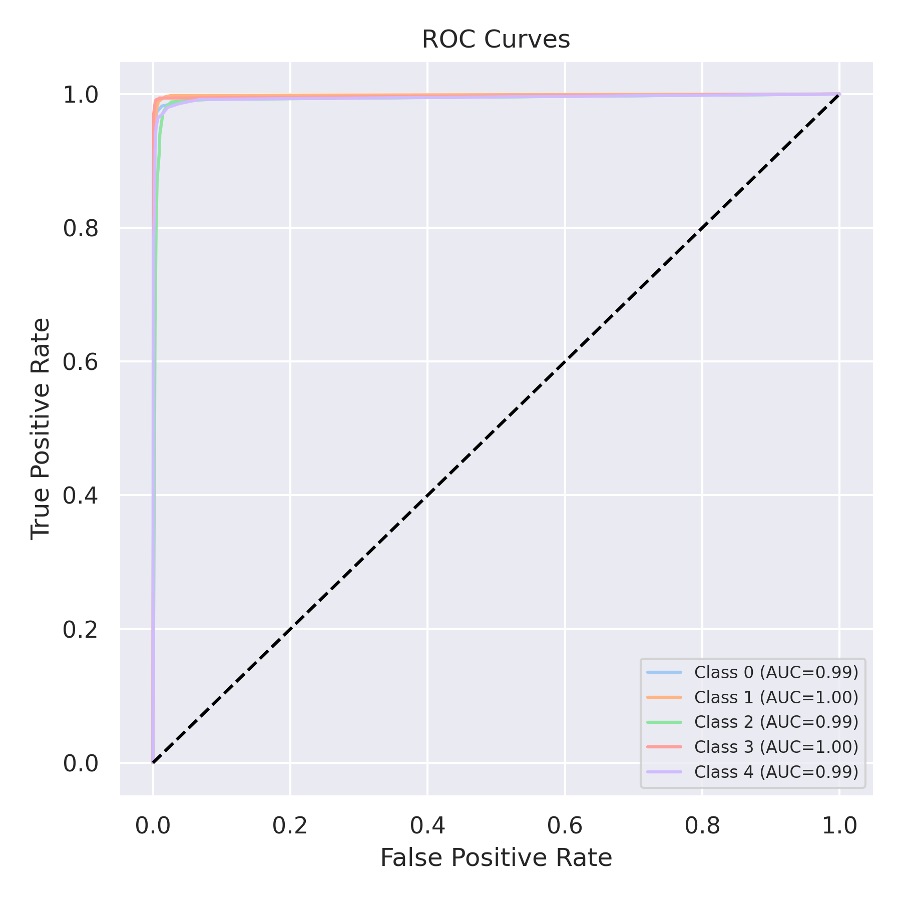

Evaluation: XGBoost
Accuracy: 0.978
Precision: 0.9780241196621111
Recall: 0.978
F1 Score: 0.9780021940815934
Jaccard Index: 0.9571116565424216
Matthews CorrCoef: 0.9725048625364691
Cohen’s Kappa: 0.9725
Specificity: 0.9945
AUC: 0.9992502
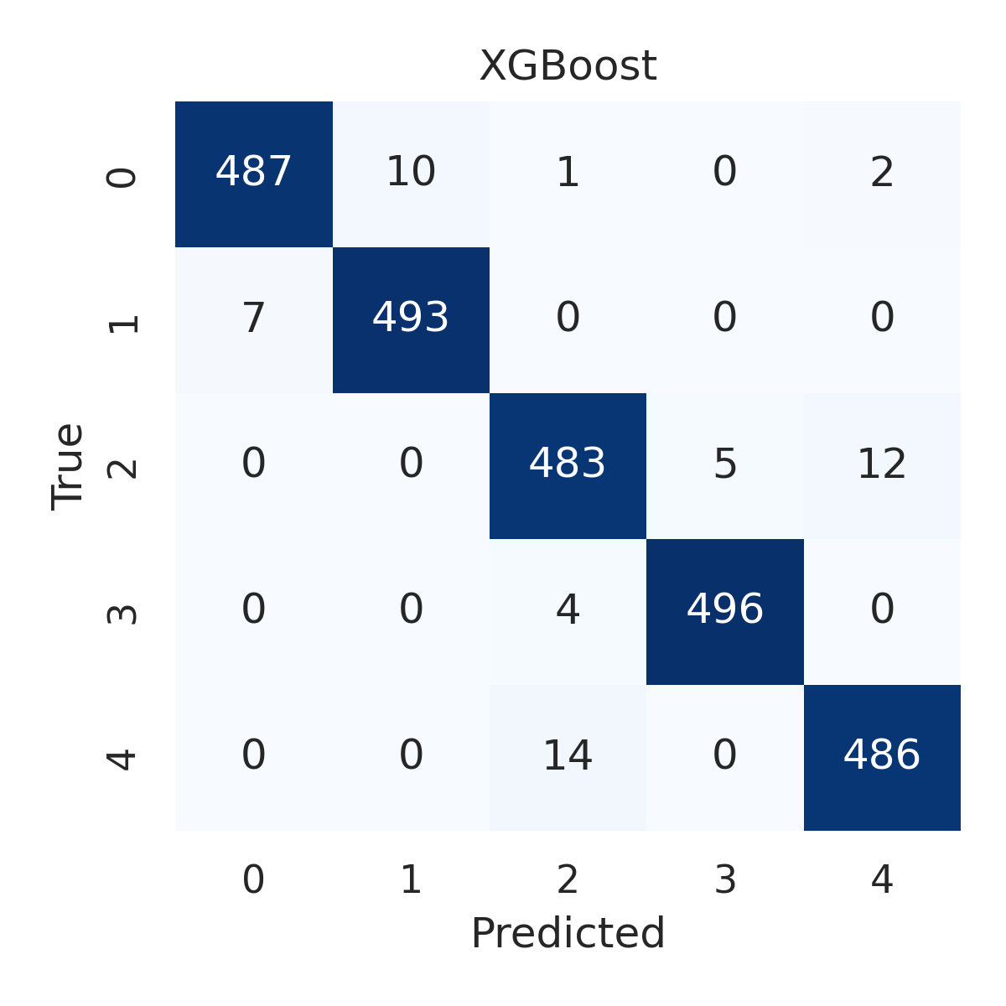

Combined ROC Curves
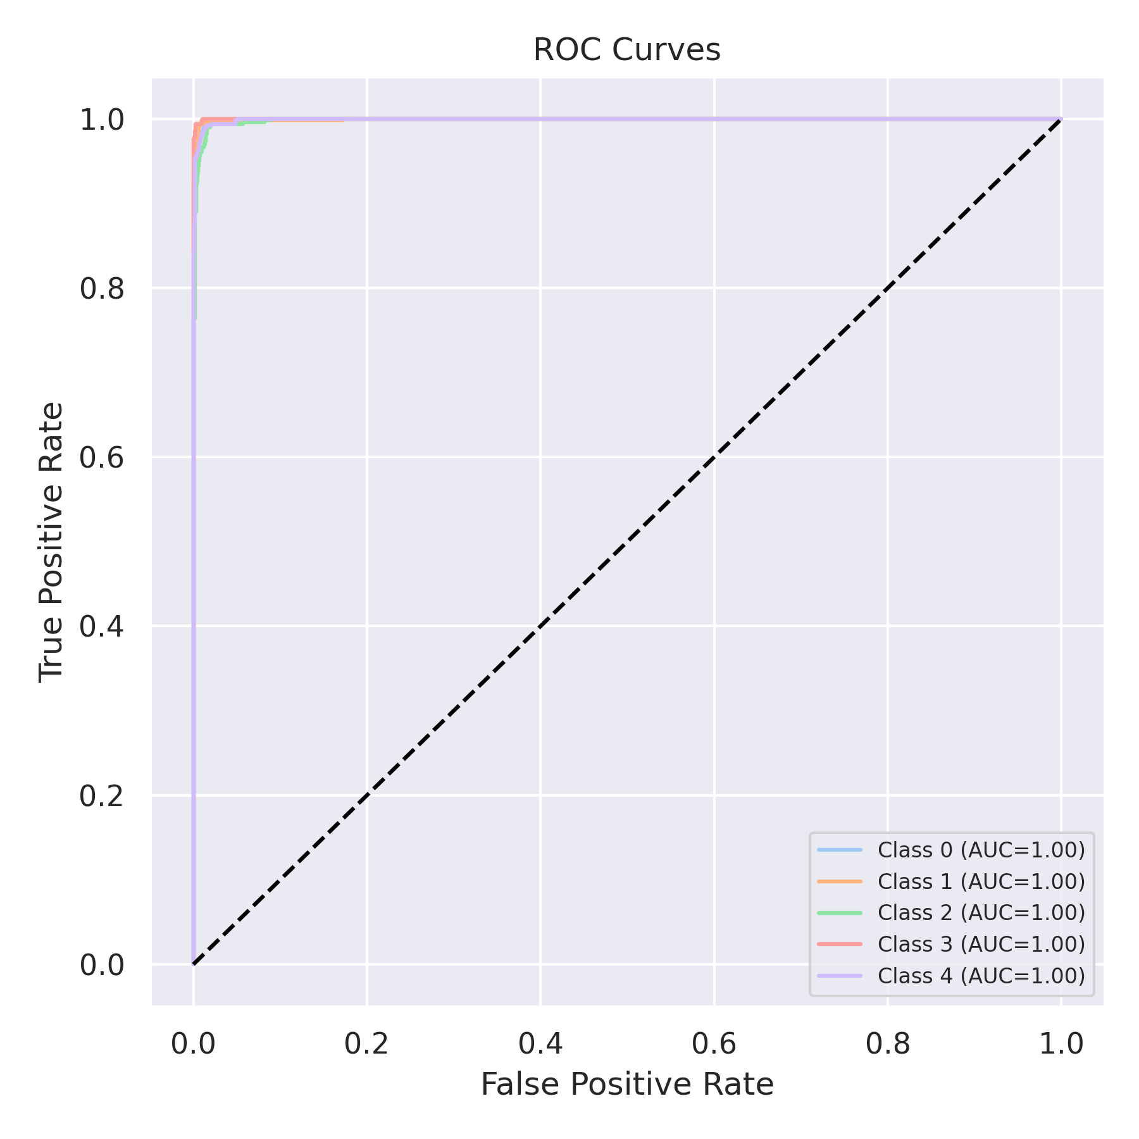

Evaluation: LightGBM
Accuracy: 0.9812
Precision: 0.9812421536590942
Recall: 0.9812
F1 Score: 0.981212551855795
Jaccard Index: 0.9633183192117288
Matthews CorrCoef: 0.9765042966283577
Cohen’s Kappa: 0.9765
Specificity: 0.9953000000000001
AUC: 0.9993242
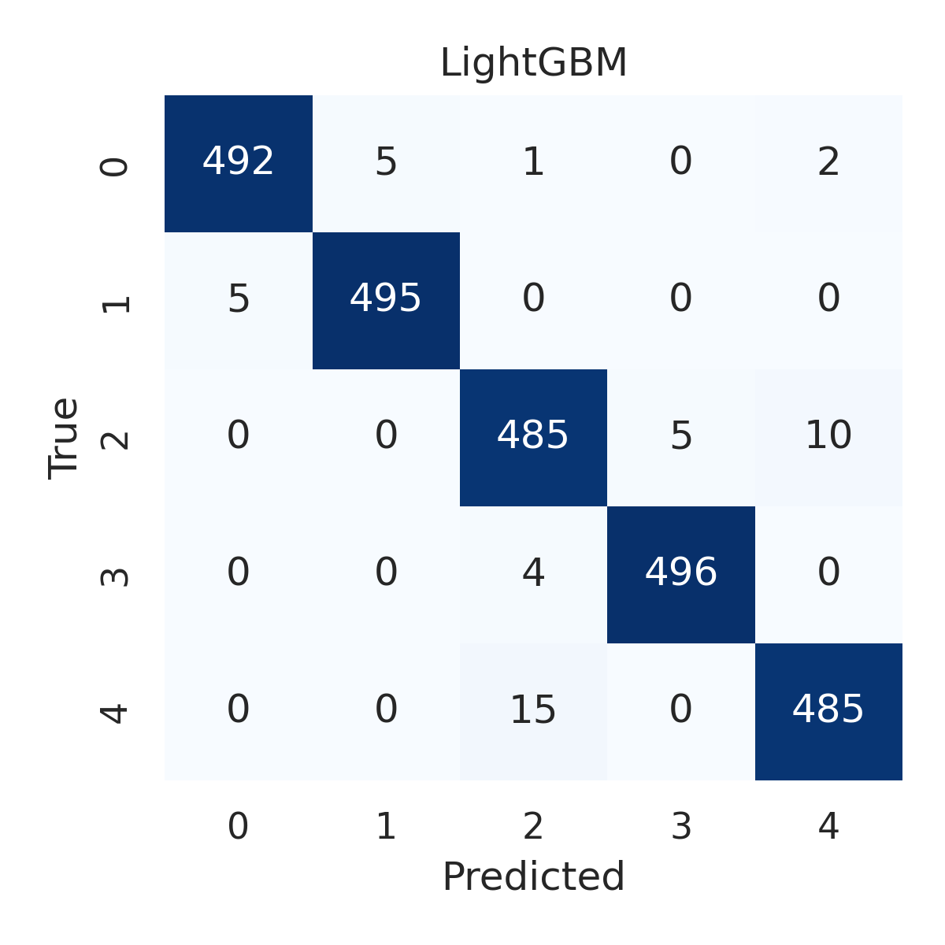

Combined ROC Curves
